web designing assignment

Term-1

Module (HTML)-1

**Q:1:** **Are the HTML tags and elements the same things?** Ans: HTML Tags are building blocks of HTML page. HTML Elements are components that are used in HTML Page.

**Q:2: what are the tags and attributes in HTML?**

Ans: HTML Tags are used to hold the HTML element.HTML element holds the content.HTML attributes are used to describe the characteristic of an HTML element in detail.

Q:3: what are the void element of HTML? With Example

Ans: A void element is an element in HTML that cannot have any child nodes. Void elements only have a start tag;end tag must not be specified for void elements.In HTML, a void element must not have an end tag.

For example, <input type=”text”></input> is invalid HTML.

**Q:4: What are HTML element? With example.**

Ans: The HTML element is everything from the start tag to the end tag.

<tagname>Content goes here…</tagname>

Example of HTML elements:

<h1>My First Heading</h1>

**Q:5: What are different types of lists in HTML**? **With example.**

Ans: HTML offers three main types of lists to present information in an organized way.

1]Ordered lists, which have an inherent order and each item

Is numbered.

2]Unordered lists, which have no inherent order and each

Item is bulleted.

3]Description lists, which contain a list of terms and

descriptions for each term.

Example:

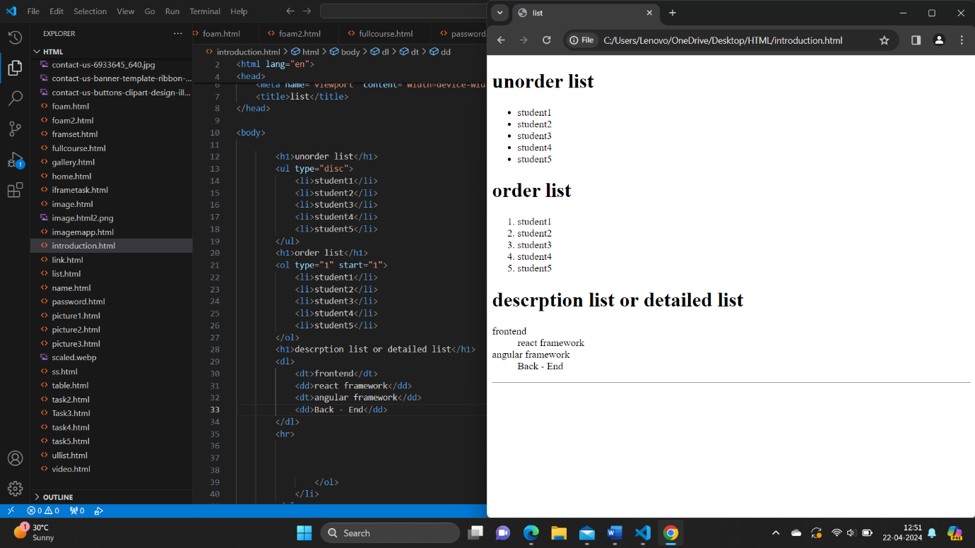

**Q:6: What is the ‘Class’ attribute in HTML? With example**.

Ans: The class attribute specifies one or more classnames for an element for an element. The class sttribute is mostly used to point to a class in a style sheet. JavaScript to make changes to HTML elements with a specified class.

Example:

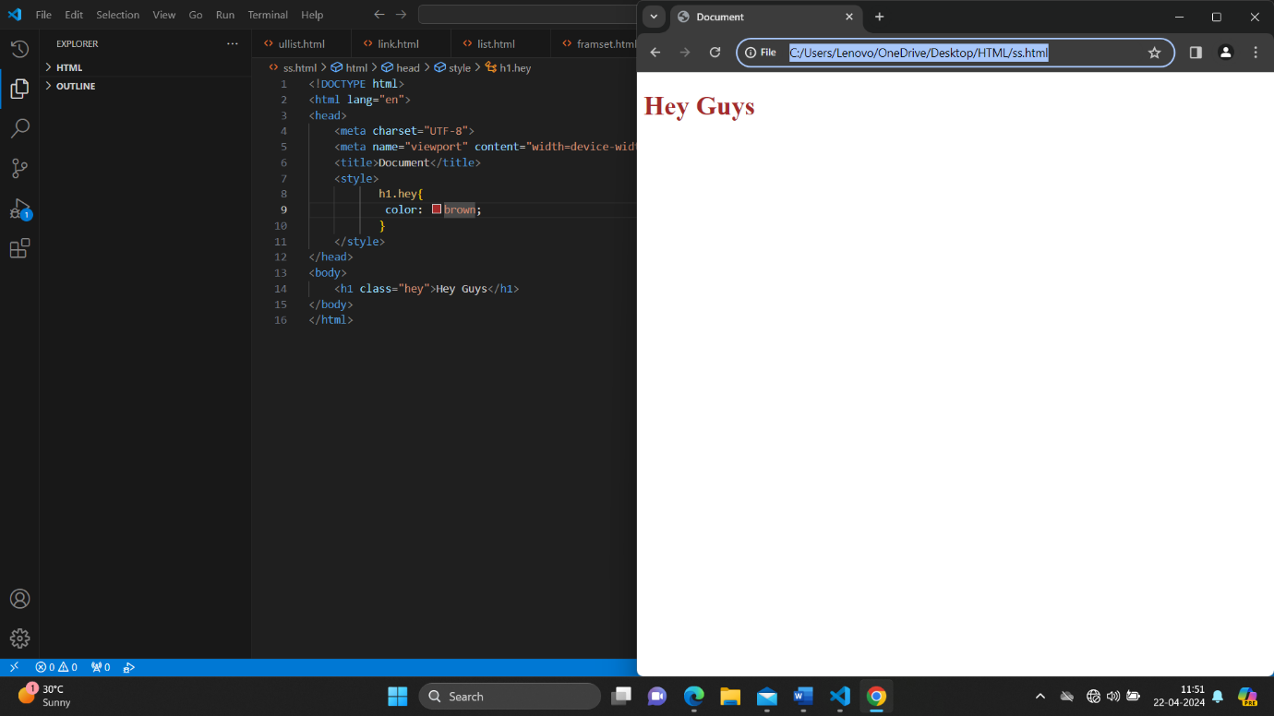

**Q:7: what is the difference between the Id attribute and the Class attribute of HTML elements? With example**.

Ans :A Class name can be used by multiple HTML elements, while an ID name must only be used by one HTML element with in the page.

Example: Id attribute

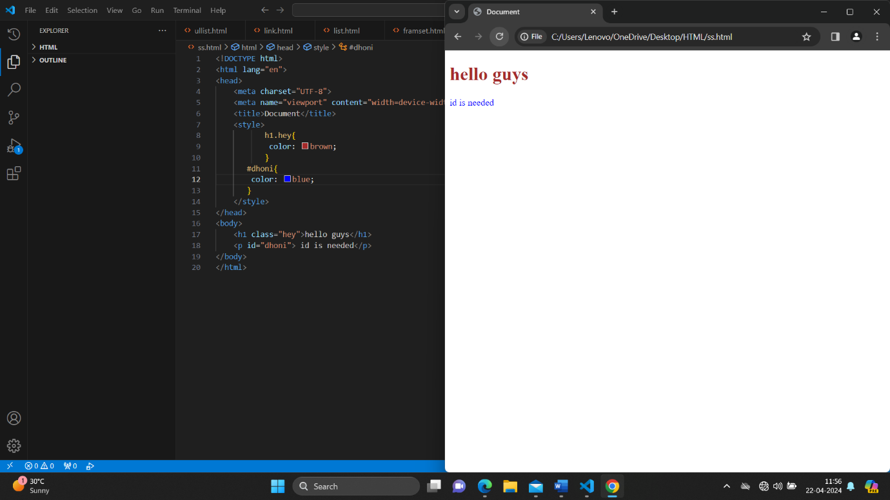

Class attribute:

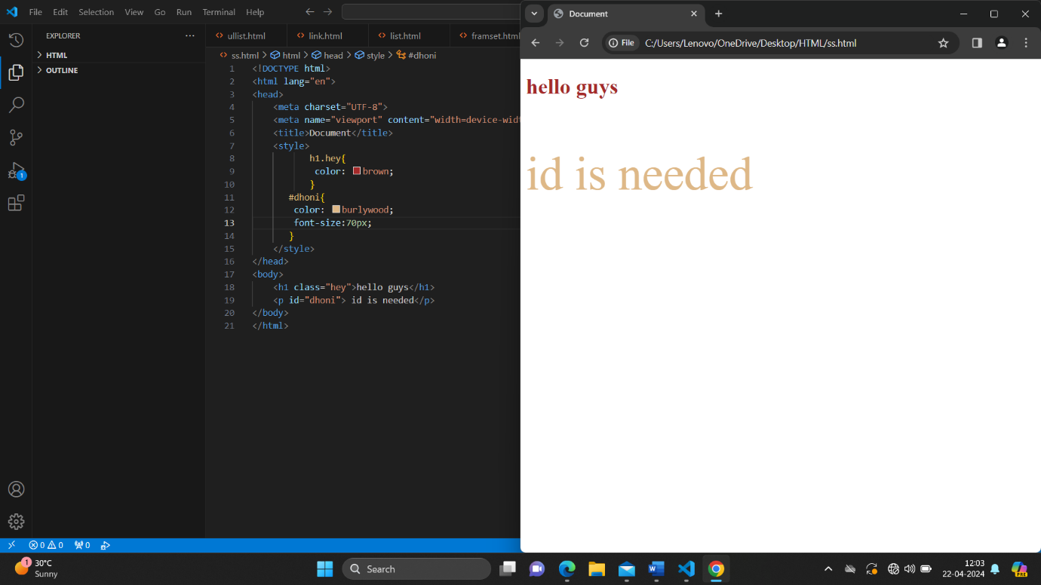

**Q:8: What are the various formatting tags in HTML**?

Ans: HTML offers various tags to format text, like

-bold<b> or <strong> important

-italic<i> or <em> emphasized

- underline<u>

-deleted<del>

-Highlight<mark>

**Q:9: How is cellpadding different from cellspacing? with example.**

Ans. Cell padding is used to create a border around the content area of a wed page¸ whereas cell spacing is used for positioning elements within that content area.

Example:

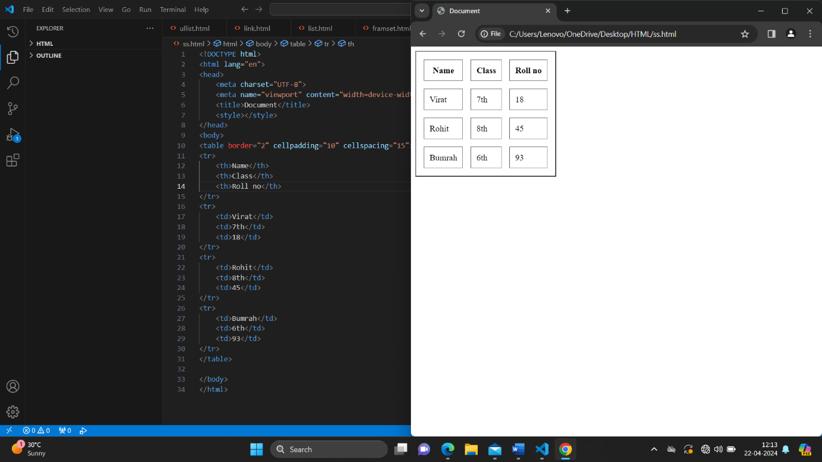

**Q:10: How can we club two or more rows and columns into a single row and column in an HTML table? With example**.

Ans. We use colspan and rowspan attribute, to merge cells in HTML. The rowspan attribute is for the number of rows a cell should merge, whereas the colspan attribute is for the number of columns a cell should merge. The attribute should be placed inside the <td> tag.

Example:

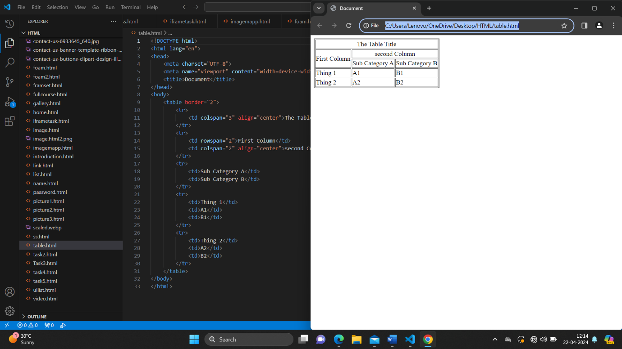

**Q:11: What is the different between a block- level element and an inline element?**

Ans: Block element: It occupy the full width irrespective of their sufficiency.

Inline element: It occupy only sufficient width required.

**Q:12: How to create a hyperlink in HTML? With example.**

Ans: Use the URL for the link in the ‘a href=”…” ’ tag.

Example:

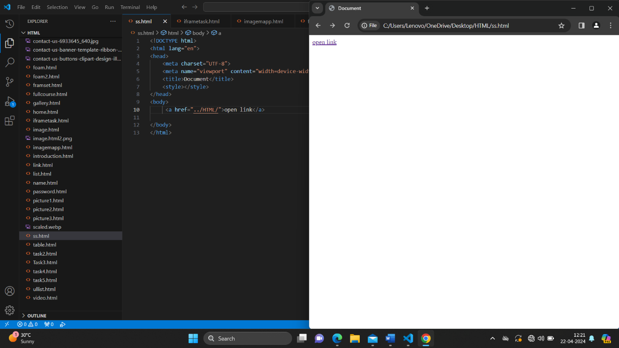

**Q:13: What is the use of an iframe tag? Explain this Example.**

Ans: The <iframe> tag in HTML is used to embed another HTML document within the current document. Its commonly used for embedding content like maps, vidoes, documents from another website.

Example:

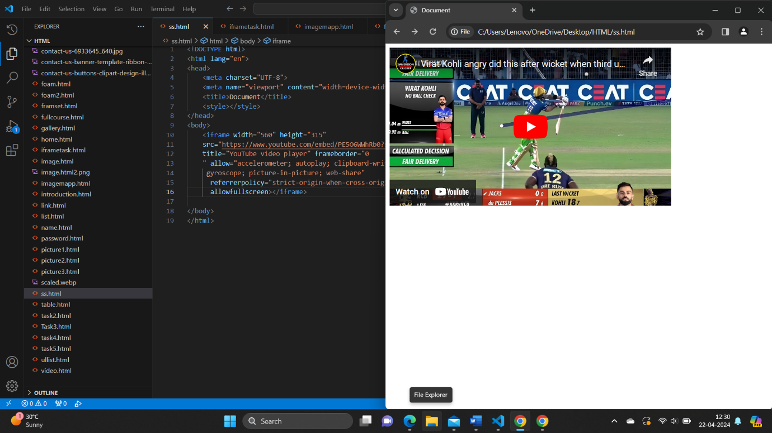

**Q:14: What is the use of a span tag ? Explain with example?**

Ans: The <span> tag in HTML is used to apply style to Inline elements without changing the structure’

Example:

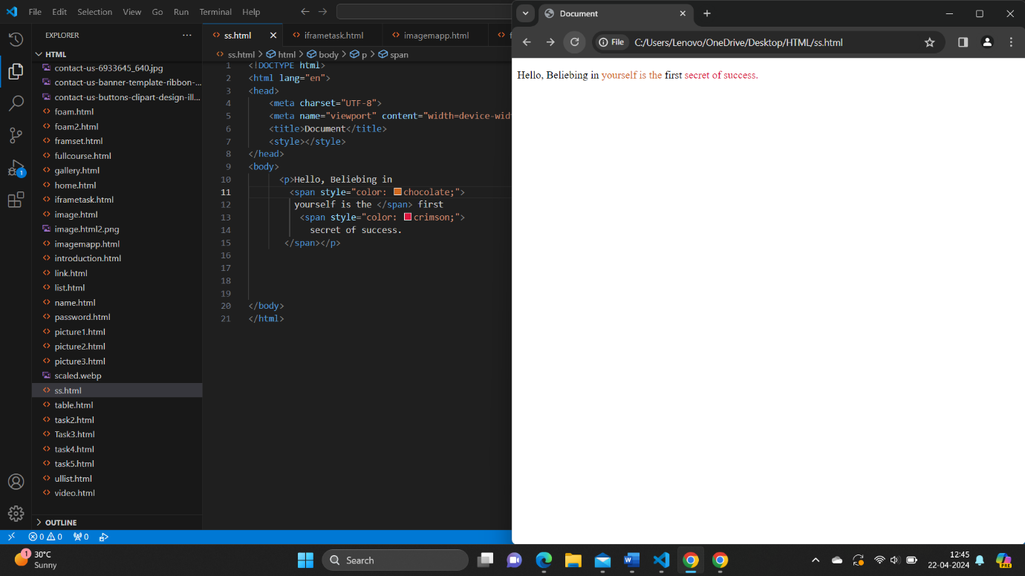

**Q:15: How to insert a picture into a background image of a** **web page?**

Ans: Inset a picture into background image of a web page , we can use css.

Background-image , and then a picture is inserted as a background image in an HTML element with the class. Picture we can adjust the background size , width and height properties as needed.

**Q:16: How are active links different from normal link?**

Ans: Active links, also known as hyperlink, are links that are click and lead to another location, such as another webpage or a file. Normal links, on the other hand, are simply text or elements that indicate a connection to another location but

Are not interactive or clickable. Essentially, active links allow

Users to navigate to other resources or pages, while normal links are ststic and don’t have that functionality.

**Q:17: What are the different tags to separate sections of** **text?**

Ans: In HTML, we can use various tags to separate sections of text:

<div>, <p>, <h1> to <h6>, <section>, <article>, <header>, <footer>, <aside>, <blockquote>.

**Q:18: What is SVG?**

Ans: SVG stands for Scalable Vector Graphics. It’s a markup language used to describe two-dimensional vector graphics. SVG file are XML-based and can be scaled to any size without losing quality, making them ideal for logos, icons, illustration, and other graphics on the web.

**Q:19: What is difference between HTML and XHTML/**

Ans: HTML :- Hypertext Markup Language.

XHTML :- Extensible Hypertext Markup Language.

Both Markup Language used for creating and displaying web pages.

The main difference between them is the syntax and structure : HTML is more lenient in its syntax, while XHTML has a more strict syntax and follows XML rules.

**Q:20: What are logical and physical tags in HTML?**

Ans: Logical Tags: It refer to elements that define the structure and semantics of a web page.

Ex: <header>, <nav>, <footer>, <section>, <article>, etc.

Physical Tags: It refer to elements that define how content should be displayed.

Ex: <b> Bold, <i> italic, <u> underline, etc.